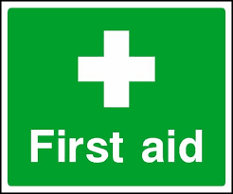 Emergency Action Plan
RAL RecSoc Pitch
This document is intended to help deliver an effective medical response in the event of a player, member of staff or spectator being injured or becoming ill whilst on site at a Harwell Recreation Ground

Club Name | Harwell & Hendred Youth Football Club
Location | OX11 0DE, RAL RecSoc Pitch, Road 7, Harwell Campus
In Emergency | Dial RAL security on 01235 778888 and ask for emergency first aid assistance, else  Dial 999 from any mobile phone, even if locked, follow emergency dialling screen prompts. Inform security on 01235 445545 that an ambulance is coming to scene
First-Aider Information
All HHYFC managers and coaches hold an Emergency First Aid Certificate (as a minimum) from the FA. They will be able to assist in the event of a medical emergency or should you require any assistance.
RAL Security on 1235 445545 can also provide advise/assistance as required
Ambulance Access Route
Vehicle access to pitches. From the A4185 Newbury Road, turn into the Fermi Avenue Harwell Campus entrance. Turn left at the roundabout into Road 7and follow the road round to the right. Entrance onto the pitches is on the left-hand side via the double metal gates, as shown by the red arrow below.
What3Words: Vehicular pitch access: https://w3w.co/march.solar.named
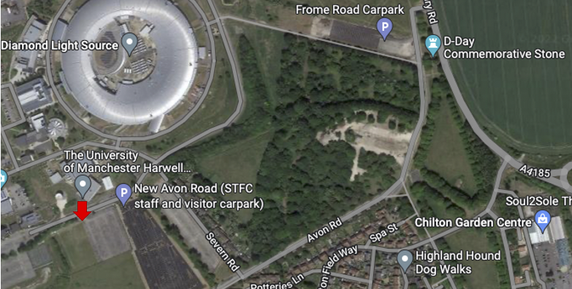
Closest A&E Hospital
Nearest Hospital (with A&E Dept.) | John Radcliffe Hospital, Headley Way, Headington, Oxford, OX3 9DU.  Open 24 hours. Tel 01865 741166  18.4 miles. Journey time approx. 35 mins:
Directions to Hospital | Follow Road 7 back to the roundabout and take the 3rd exit right onto Fermi Avenue. Exit Harwell Campus, turning right onto Newbury Road, A4185. At the roundabout, take the 1st exit onto the A34 heading north. After 12.5 miles, exit the A34 at the Oxford Ring Road/Southern Bypass. Turn left at the next roundabout onto the A4144. Turn right onto Weirs Lane/B4495 and left at the end of the road onto Iffley Road/A4158. At the roundabout, take the 3rd exit onto St Clements St./A420. Turn left at the mini roundabout onto Marston Road/B4150. After 0.8 miles, turn right at the mini roundabout onto Jack Straws Lane and straight into Staunton Road. Turn left onto Headley Way/B4495 and then immediately right at the roundabout into the hospital approach.
Last Reviewed | September 2022

