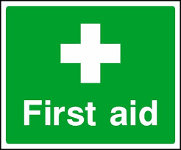 Emergency Action Plan
Harwell Campus Archery Field
This document is intended to help deliver an effective medical response in the event of a player, member of staff or spectator being injured or becoming ill whilst on site at a Harwell & Hendred Youth club match at the Harwell Campus Archery Field site

Club Name | Harwell & Hendred Youth Football Club
Location | OX11 0QB, Thomson Avenue, Harwell Campus
In Emergency | Dial 999 from any mobile phone, even if locked, follow emergency dialling screen prompts
First-Aider Information
All HHYFC managers and coaches hold an Emergency First Aid Certificate (as a minimum) from the FA. They will be able to assist in the event of a medical emergency or should you require any assistance
First Aid Equipment & Facilities
Item | Location
Defibrillator | A defibrillator is located within the cricket pavilion marked with the green heart in the map shown below. HHYFC managers have the code to enter the pavilion building  What3Words Address: Defibrillator location: https://w3w.co/frocks.skimmers.paddocks
Stretcher | Located within the cricket pavilion. HHYFC managers have the code to enter the pavilion.
First Aid Room | Team manager’s first aid kit in the relevant Technical Area/Medical Bag.
Ambulance Access Route
Vehicle access to pitches. Turn into Thomson Avenue from the Newbury Road, A4185. After the zebra crossing, turn left into the car park and straight through the gate onto the pitch
What3Words: Vehicular site entrance: https://w3w.co/turkeys.dupe.revival
What3Words: Vehicular pitch access: https://w3w.co/digesting.desks.gossiping
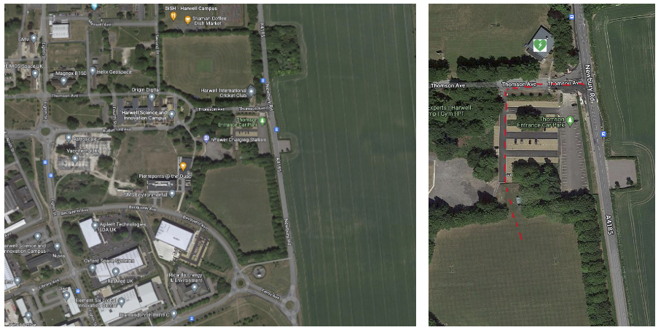
Closest A&E Hospital
Nearest Hospital (with A&E Dept.) | John Radcliffe Hospital, Headley Way, Headington, Oxford, OX3 9DU.  Open 24 hours. Tel 01865 741166  18 miles. Journey time approx. 35 mins:
Directions to Hospital | Exit Harwell Campus, via Thomson Avenue, turning right onto Newbury Road, A4185. At the roundabout, take the 1st exit onto the A34 heading north. After 12.5 miles, exit the A34 at the Oxford Ring Road/Southern Bypass. Turn left at the next roundabout onto the A4144. Turn right onto Weirs Lane/B4495 and left at the end of the road onto Iffley Road/A4158. At the roundabout, take the 3rd exit onto St Clements St./A420. Turn left at the mini roundabout onto Marston Road/B4150. After 0.8 miles, turn right at the mini roundabout onto Jack Straws Lane and straight into Staunton Road. Turn left onto Headley Way/B4495 and then immediately right at the roundabout into the hospital approach.
Last Reviewed | October 2022

