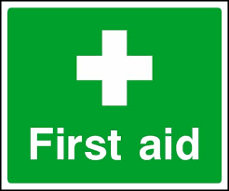 Emergency Action Plan
Harwell Recreation Ground
This document is intended to help deliver an effective medical response in the event of a player, member of staff or spectator being injured or becoming ill whilst on site at a Harwell Recreation Ground

Club Name | Harwell & Hendred Youth Football Club
Location | OX11 0LG, Harwell Recreation Ground, Westfield, Harwell
In Emergency | Dial 999 from any mobile phone, even if locked, follow emergency dialling screen prompts
First-Aider Information
All HHYFC managers and coaches hold an Emergency First Aid Certificate (as a minimum) from the FA. They will be able to assist in the event of a medical emergency or should you require any assistance
First Aid Equipment & Facilities
Item | Location
Defibrillator | A defibrillator is located at Harwell Village Hall, 0.2 miles away from the scout hut  What3Words Address: Defibrillator location: https://w3w.co/bids.deodorant.carbonate
Stretcher | None on site
First Aid Room | Team manager’s first aid kit in the relevant Technical Area/Medical Bag.
Ambulance Access Route
Vehicle access to pitches. Turn into the Harwellian Club car park. Entrance onto the pitches is to the left of the club building main entrance, as shown by the red arrow dotted line below.
What3Words: Vehicular pitch access: https://w3w.co/stitch.symphonic.product
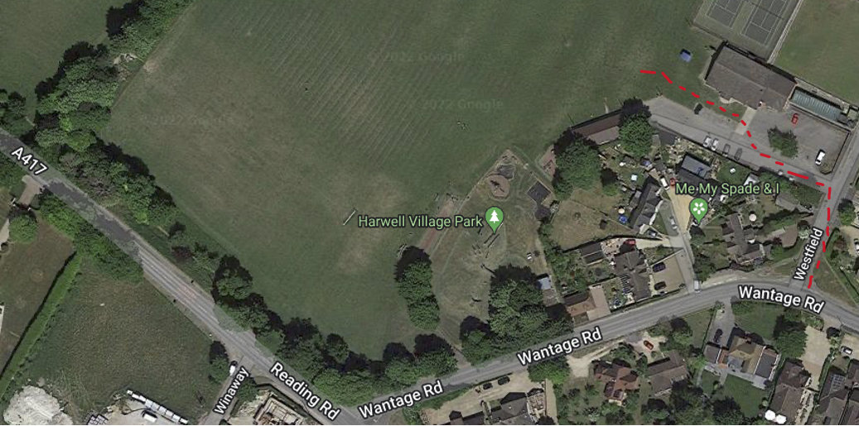
Closest A&E Hospital
Nearest Hospital (with A&E Dept.) | John Radcliffe Hospital, Headley Way, Headington, Oxford, OX3 9DU.  Open 24 hours. Tel 01865 741166  15.9 miles. Journey time approx. 35 mins:
Directions to Hospital | From the Harwellian Car park, turn right into Westfield, right into Wantage road and then right again onto the A417 Reading Road. At the Rowstock roundabout, take the 3rd exit and head north on the Abingdon Road, A4130 to the Milton Interchange. Take the 1st exit onto the A34 heading north. After 8.5 miles, exit the A34 at the Oxford Ring Road/Southern Bypass. Turn left at the next roundabout onto the A4144. Turn right onto Weirs Lane/B4495 and left at the end of the road onto Iffley Road/A4158. At the roundabout, take the 3rd exit onto St Clements St./A420. Turn left at the mini roundabout onto Marston Road/B4150. After 0.8 miles, turn right at the mini roundabout onto Jack Straws Lane and straight into Staunton Road. Turn left onto Headley Way/B4495 and then immediately right at the roundabout into the hospital approach.
Last Reviewed | September 2022

