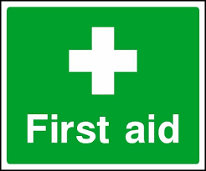 Emergency Action Plan
Boundary Park
This document is intended to help deliver an effective medical response in the event of a player, member of staff or spectator being injured or becoming ill whilst on site at a Harwell & Hendred Youth club match at our ‘home’ site – Boundary Park

Club Name | Harwell & Hendred Youth Football Club
Location | OX11 6GD, Boundary Park Sports Ground, Greenwood Way, Didcot
In Emergency | Dial 999 from any mobile phone, even if locked, follow emergency dialling screen prompts
First-Aider Information
All HHYFC managers and coaches hold an Emergency First Aid Certificate (as a minimum) from the FA. They will be able to assist in the event of a medical emergency or should you require any assistance
First Aid Equipment & Facilities
Item | Location
Defibrillator | A defibrillator is located on the right-hand corner of the pavilion, facing the car park, as marked with the green heart in the map shown below.  What3Words Address: Defibrillator location: https://w3w.co/brings.pacemaker.blanket
Stretcher | None on site
First Aid Room | Team manager’s first aid kit in the relevant Technical Area/Medical Bag.
Ambulance Access Route
Vehicle access to pitches. Turn into car park at the corner of Greenwood Way & Harebell Road. Entrance onto the pitches is to the right of the pavilion building, between the wooden bin storage and the Bicycle shelter, through the double gates, as shown by the red arrow markers below. Managers have the key code.
What3Words: Vehicular site entrance: https://w3w.co/rotations.however.shopper
What3Words: Vehicular pitch access: https://w3w.co/rentals.clarifies.falls
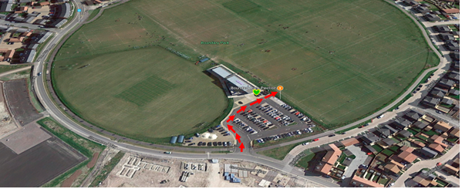
Closest A&E Hospital
Nearest Hospital (with A&E Dept.) | John Radcliffe Hospital, Headley Way, Headington, Oxford, OX3 9DU.  Open 24 hours. Tel 01865 741166  15.7 miles. Journey time approx. 35 mins:
Directions to Hospital | Follow Greenwood Way into Sir Frank Williams Avenue. Turn left at the traffic lights onto the A4130. At the Milton Interchange roundabout, turn right and follow the A34 north for 8.6 miles. Exit the A34 at the Oxford Ring Road/Southern Bypass. Turn left at the next roundabout onto the A4144. Turn right onto Weirs Lane/B4495 and left at the end of the road onto Iffley Road/A4158. At the roundabout, take the 3rd exit onto St Clements St./A420. Turn left at the mini roundabout onto Marston Road/B4150. After 0.8 miles, turn right at the mini roundabout onto Jack Straws Lane and straight into Staunton Road. Turn left onto Headley Way/B4495 and then immediately right at the roundabout into the hospital approach.
Last Reviewed | September 2023

